**University of Asia Pacific**

Department of Electrical & Electronic Engineering

EEE 401: Energy Conversion and special machines

Module 2: Wind Energy



**Module 4: Wind Energy**

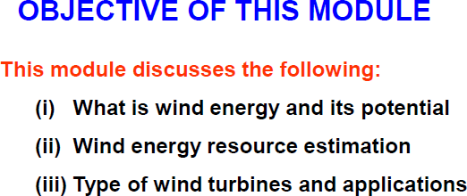

**Module 4: Wind Energy**

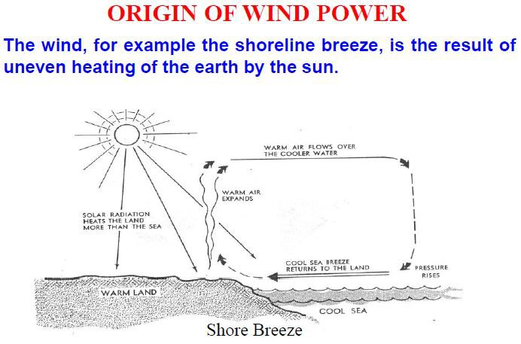

**Module 4: Wind Energy**

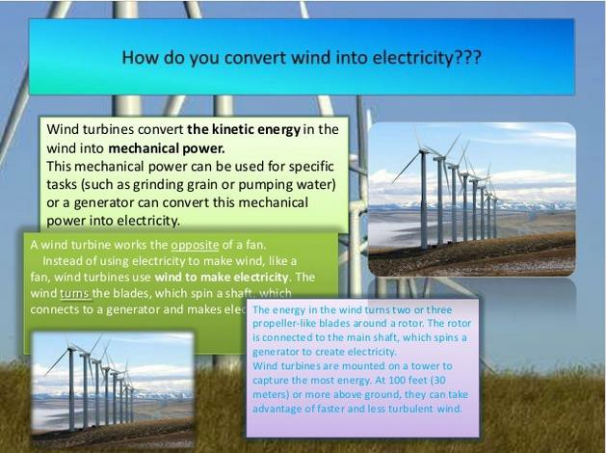

**Module 4: Wind Energy**

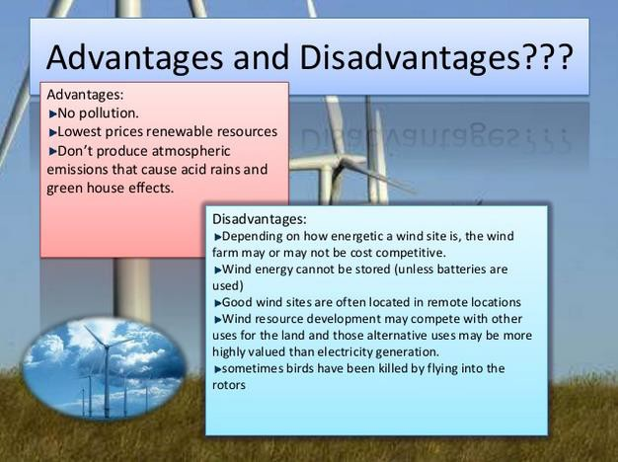

**Module 4: Wind Energy**

***Wind Turbine Design***

Two types of turbine design are possible – ***Horizontal axis*** *and* ***Vertical axis***. In horizontal axis turbine, it is possible to catch more wind and so the power output can be higher than that of vertical axis. But in horizontal axis design, the tower is higher and more blade design parameters have to be defined. In vertical axis turbine, there is no cyclic load on the blade, thus it is easier to design. Maintenance is easier in vertical axis turbine whereas horizontal axis turbine offers better performance.

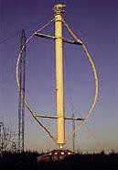**Vertical axis Turbine (VAT)**



**Horizontal axis Turbine (HAT)**

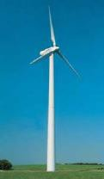6



**Module 4: Wind Energy**

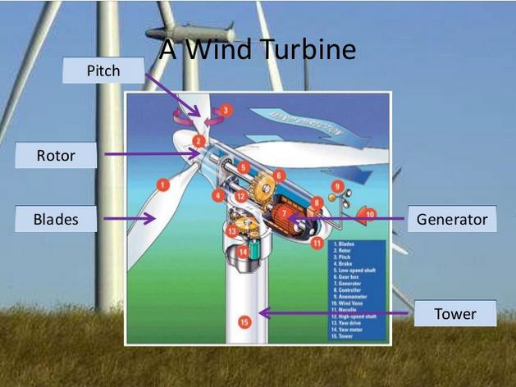

7

***Main components of a Horizontal Axis Wind Turbine***

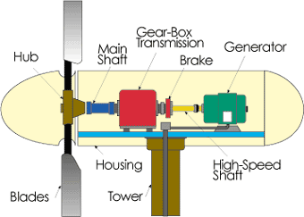

**Rotor:** Converts the wind power to a rotational mechanical power.

**Generator:** Converts the rotational mechanical power to electrical power.

**Gear box:** Wind turbines rotate typically between 20 rpm and 400 rpm. Generators typically rotates at 1,200 to 1,800 rpm. Most wind turbines require a step-up gear-box for efficient

generator operation (electricity production). 8

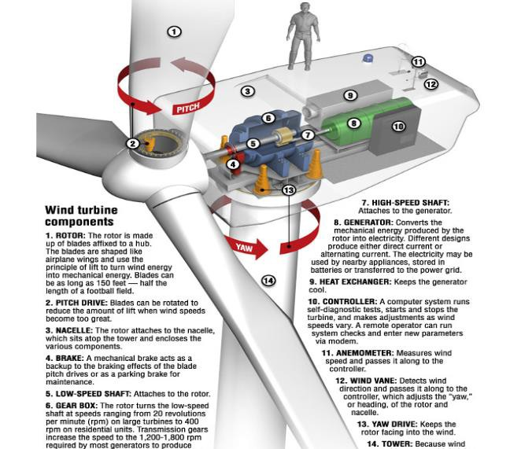

Engineering 10, SJSU 9



**Module 4: Wind Energy**

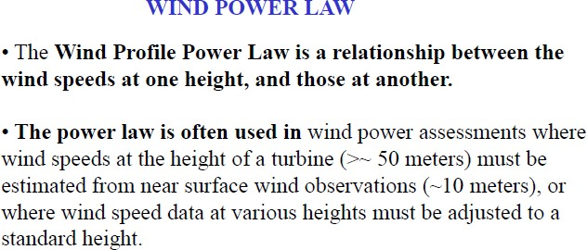

**Module 4: Wind Energy**

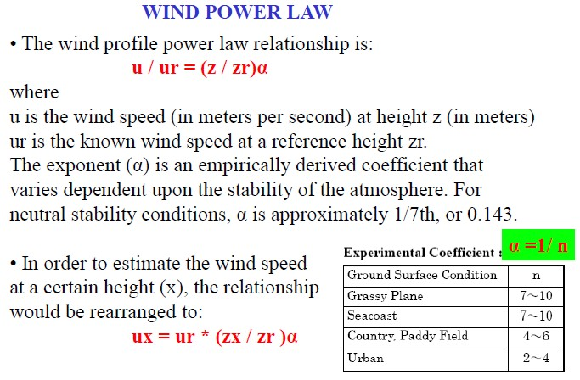

**Module 4: Wind Energy**

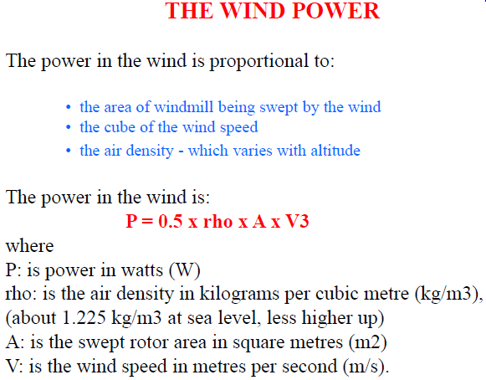

**Module 4: Wind Energy**

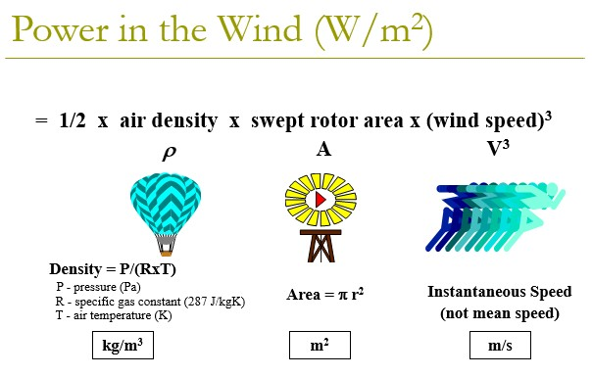

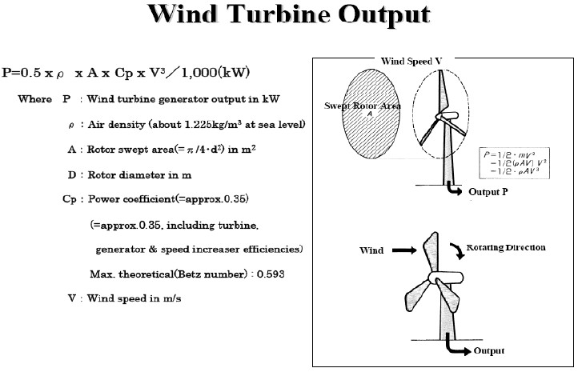



**Module 4: Wind Energy**

# Typical Wind Turbine Operation

**0 ~ 10 mph** --- Wind speed is too low for generating power. Turbine is not operational. *Rotor is locked*.

**10 ~ 25 mph ---** 10 mph is the minimum operational speed. It is called “*Cut-in speed*”. In 10 ~ 25 mph wind, generated power increases with the wind speed.

**25 ~ 50 mph ---** Typical wind turbines reach the rated power (maximum operating power) at wind speed of 25mph (called *Rated wind speed*). Further increase in wind speed will not result in substantially higher generated power by design. This is accomplished by, for example, pitching the blade angle to reduce the turbine efficiency.

**> 50 mph ---** Turbine is shut down when wind speed is higher than 50mph (called “Cut-out” speed) to prevent structure failure.

***Cut-in Speed***

# Wind Turbine

Cut-in speed is the minimum wind speed at which the wind turbine will generate usable power. This wind speed is typically between 7 and 15 mph.

## Rated Speed

The rated speed is the minimum wind speed at which the wind turbine will generate its designated rated power. For example, a "10 kilowatt" wind turbine may not generate 10 kilowatts until wind speeds reach 25 mph. Rated speed for most machines is in the range of 25 to 35 mph. At wind speeds between cut-in and rated, the power output from a wind turbine increases as the wind increases.

## Cut-out Speed

At very high wind speeds, typically between 50 and 80 mph, most wind turbines cease power generation and shut down. The wind speed at which shut down occurs is called the cut-out speed. Having a cut-out speed is a safety feature which protects the wind turbine from damage. Shut down may occur in one of several ways. In some machines an

**Module 4: Wind Energy**

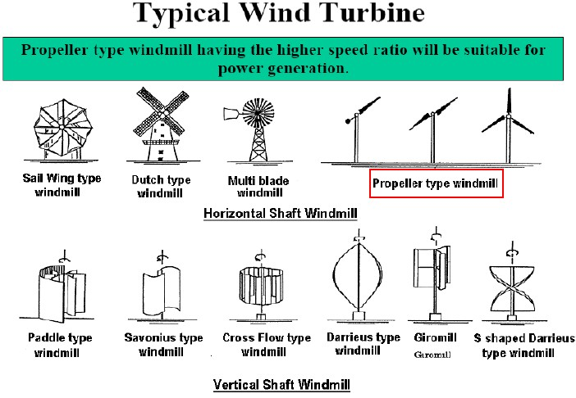

**Module 4: Wind Energy**

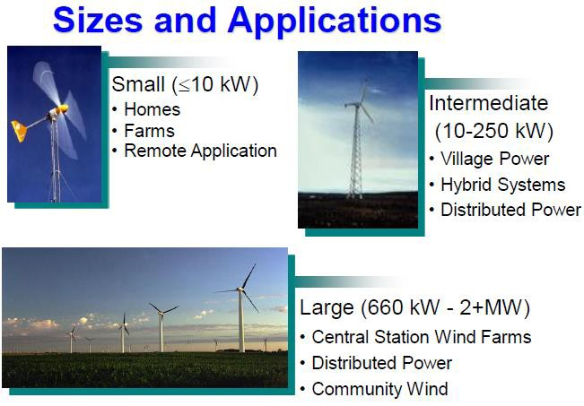

**Module 4: Wind Energy**

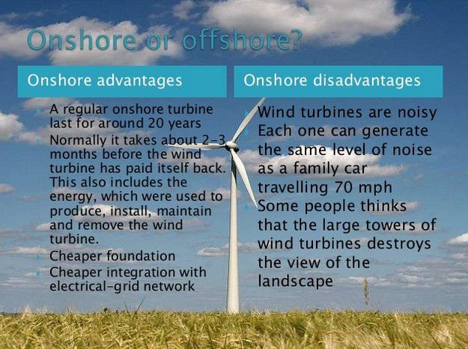

**Module 4: Wind Energy**

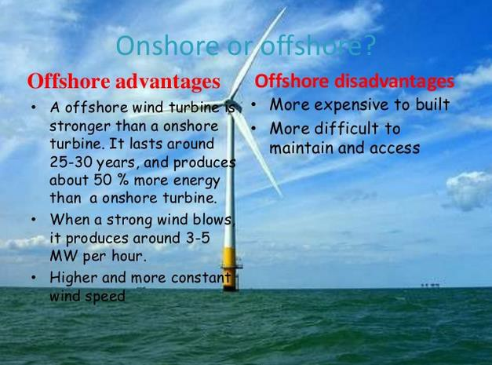

**Wind energy is a kind of solar energy. Wind energy describes the process by which wind is used to produce electricity. The wind turbines convert the kinetic energy present in the wind to mechanical power.**

**Wind energy is a renewable source of energy that determines the total power in the wind. The wind turbines which convert kinetic energy to mechanical power, wherein the mechanical power is converted into electricity which acts as a useful source.**

**The wind energy formula is given by,**

**Wind energy formula**

**Where,**

**P = power,**

**ρ = air density,**

**A = swept area of blades given by Area formula**

**where r is the radius of the blades.**

**V = velocity of the wind.**

**Example 1**

**Determine the power in the wind if the wind speed is 20 m/s and blade length is 50 m.**

**Solution:**

**Given:**

**Wind speed v = 20 m/s,**

**Blade length l = 50 m,**

**Air density ρ = 1.23 kg/m.**

**The area is given by, Area formula**

**A = π × 2500**

**= 7850 m**

**The wind power formula is given as,**

**Wind energy formula**

**wind power calculation**

**P = 38622 W**

**Example 2**

**A wind turbine travels with the speed is 10 m/s and has a blade length of 20 m. Determine wind power.**

**Solution:**

**Given:**

**Wind speed v =10 m/s,**

**Blade length l = 20 m,**

**air density ρ = 1.23 kg/m3,**

**area ,Area formula**

**= π × 400**

**= 1256 **

**The wind power formula is given as,**

**Wind energy formula**

**= 0.5 × 1.23 × 1256 × 1000**

**P = 772440 W.**